
SHRED Fitness is pleased to host free classes for the Ward Community:
Thursday, 11/7, 9:30am Saturday, 11/9, 9:30am Tuesday, 11/19, 6:30pm

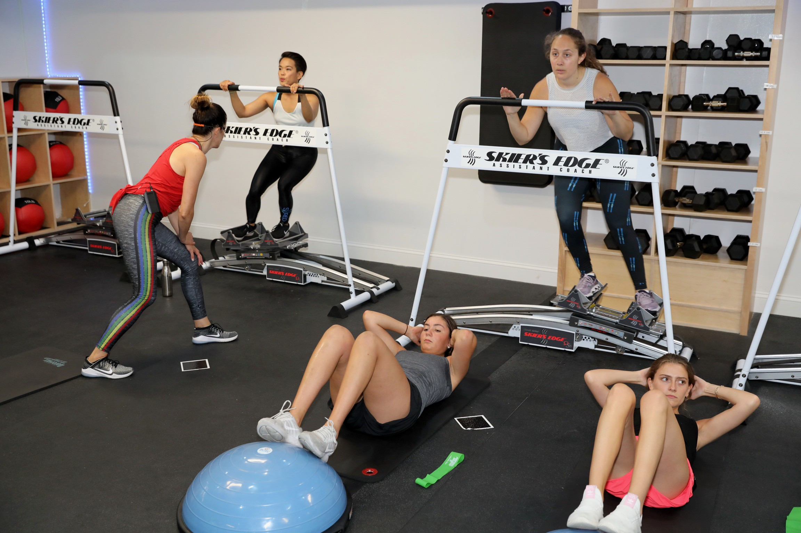
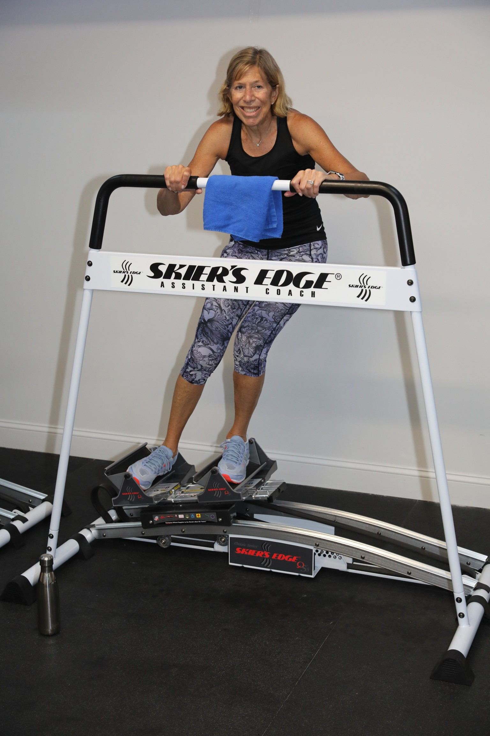
Can’t make any of these times but still want to check us out? Create an account on our site and use code FriendsFamily on a 1-class pack for your first class free!
SHRED offers 45-minute circuit based classes around the Skier's Edge. This laterally moving cardio machine strengthens the smaller stabilizer muscles in your hips and legs, making you stronger for every sport out there while preventing injury. The time on the machine is complimented with strength-based circuits on the floor, which change daily.

To sign-up, please email info@shredfitny.com. Visit us at 1481C Weaver St. Scarsdale, NY www.shredfitny.com

